**DAILY ONLINE ACTIVITIES SUMMARY**

|  |  |  |  |  |  |  |  |
| --- | --- | --- | --- | --- | --- | --- | --- |
| **Date:** | 16/06/2020 | | | | **Name:** | AMBIKA V | |
| **Sem & Sec** | 4th Sem Section'A' | | | | **USN:** | 4AL18CS005 | |
| **Online Test Summary** | | | | | | | |
| **Subject** | | Complex analysis, probability and statistical methods | | | | | |
| **Max. Marks** | | 30 | | **Score** | | 18 | |
| **Certification Course Summary** | | | | | | | |
| **Course** | Introduction to R | | | | | | |
| **Certificate Provider** | | | greatlearning academy | **Duration** | | | 3 hrs |
| **Coding Challenges** | | | | | | | |
| **Problem statement 1 :** Median of two sorted arrays of same size | | | | | | | |
| **Status:** completed | | | | | | | |
| **Uploaded the report in Github** | | | | yes | | | |
| **If yes Repository name** | | | | https://github.com/ambika0202 | | | |
| **Uploaded the report in slack** | | | | yes | | | |

**ONLINE TEST DETAILS:** The test for today was from module 1. The test was of objective type questions and there were 30 questions and the duration was 45 minutes.

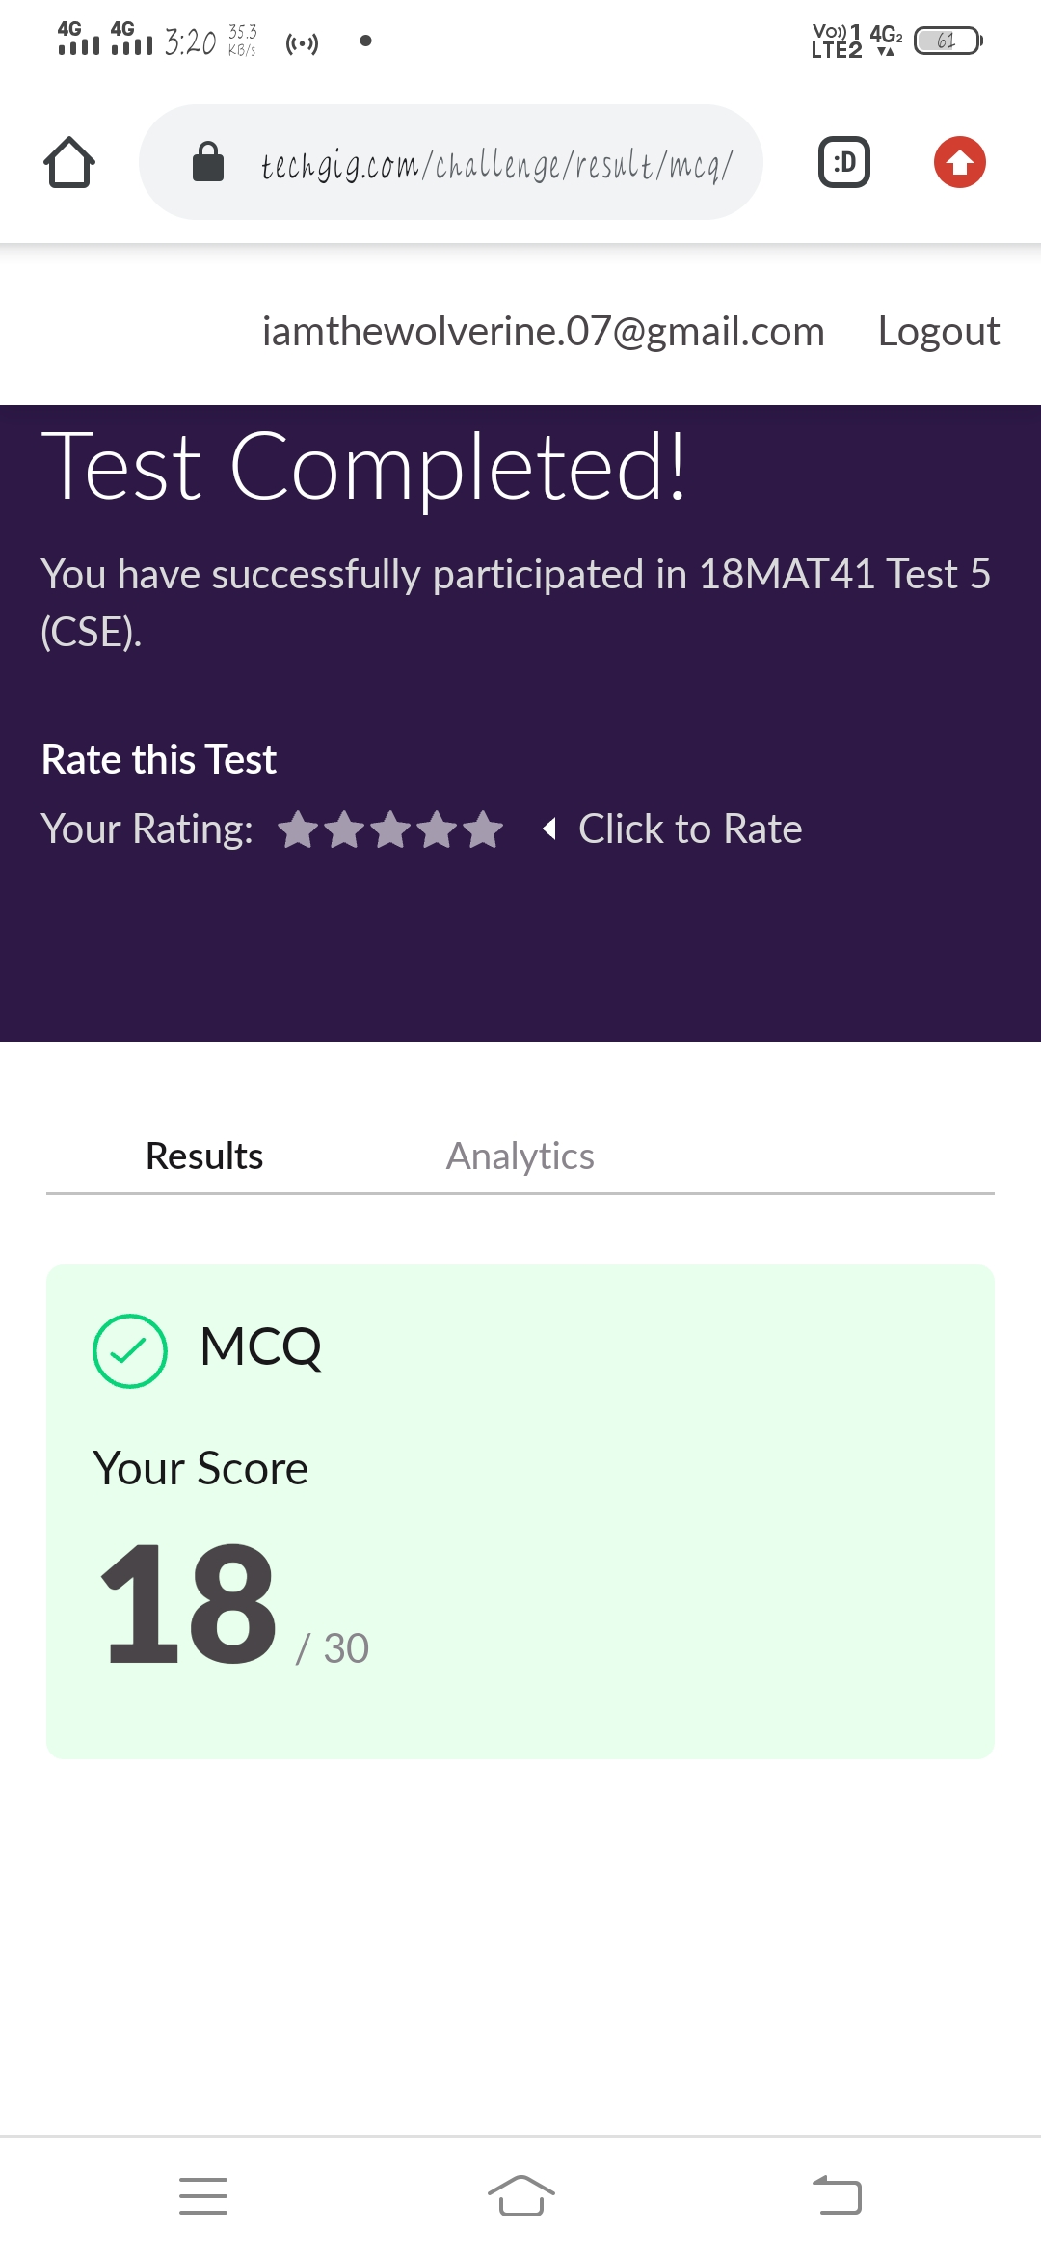

**CERTIFICATION COURSE DETAILS:**

**Name of the course**: Introduction to R.

**Certificate Provider**: Great Learning Academy

Today I have started a new course I.e., Introduction to R and started to learn about plot numedical and plot categorical.

**Snapshot:**

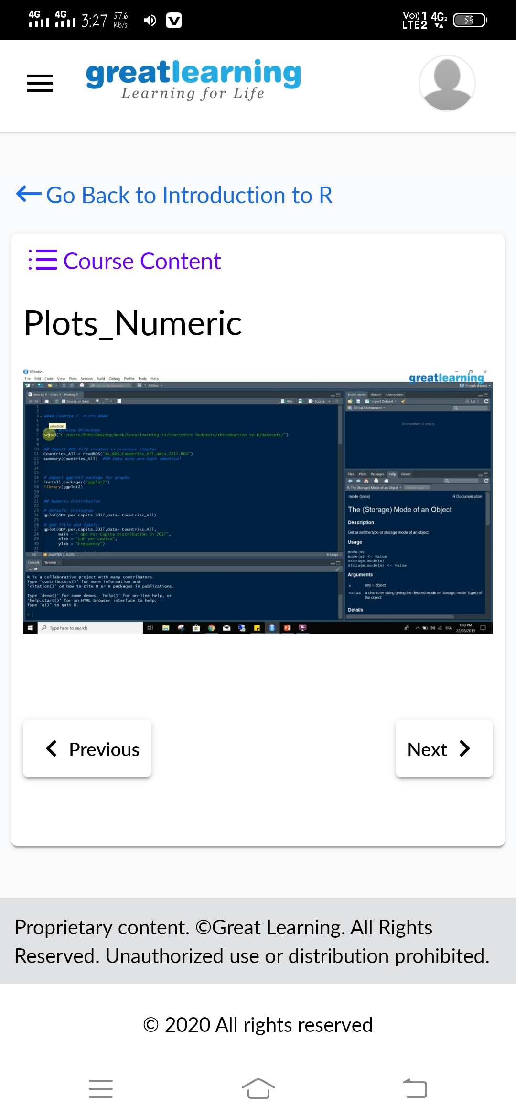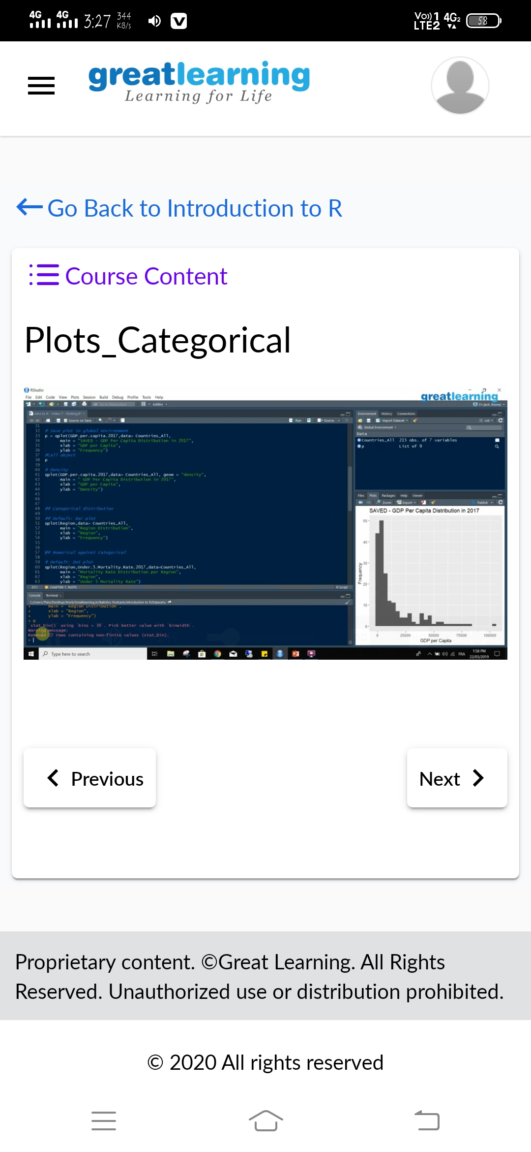

**CODING CHALLENGES DETAILS**: Every day we are given with new question of coding related to the language of java and c.

**Problem statement 1:**Median of two sorted arrays of same size

**Solution is uploaded in Github**

**Snapshot:**

